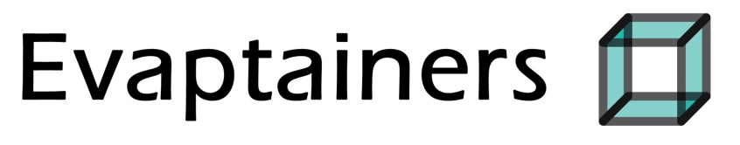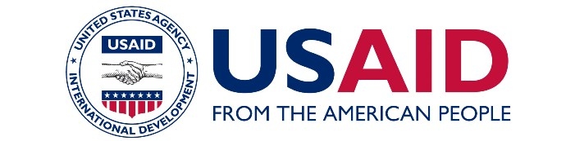

Evaptainers FINAL REPORT

DECEMBER 2, 2019

**EVAPTAINERS: Improving rural livelihoods through low-cost evaporative refrigerators**

**Grant No.:** AID-OAA-F-16-00038

**Submitted to:** United States Agency for International Development/DIV

**Prepared by**: Evaptainers, LLC

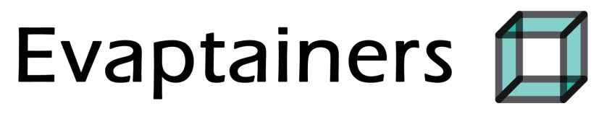

Evaptainers, LLC I 10 Tyler St. I Somerville, MA 02143

Evaptainers SARL I 13 Ave Mohammed V #04 I Sala al Jadida , Sale

1. **Abstract**

In 2016, Evaptainers LLC received a Stage 1 USAID DIV Grant to further develop a prototype for a low-cost, food preservation device that works using just water. This evaporative cooler would work similar to the Zeer Pot refrigerator (a traditional ceramic device used to preserve foods), and allow aid agencies to provide active cooling in off-grid communities, extending the cold chain to once unreachable areas. With USAIDs financial support, Evaptainers successfully completed a commercial version of their unit, which was branded as the Fenik Yuma 60L. Furthermore, they were able to bring this device into mass-production and begin sales in both the U.S. and developing markets. USAID’s financial support also allowed Evaptainers to begin preliminary field testing and market testing of the Yuma 60L device in rural areas of Morocco.

1. **Executive Summary**

Evaptainers LLC - currently rebranded as Fenik - is a hardware company based in Somerville, MA that develops and distributes low-cost refrigeration solutions. Our flagship product is the Fenik Yuma 60L, which uses a specialized synthetic fabric to harnesses the phenomenon of evaporative cooling in order to double or triple the shelf life of perishables stored inside without using any electricity. This technology allows aid agencies to provide active cooling in off-grid communities, thus extending the cold chain to once unreachable areas.

When Evaptainers initially received the USAID-DIV Stage 1, we had three primary goals under the terms of the grant:

1. Since we only had a working prototype at that point, our first goal was to continue conducting the research and development required to complete the design and create a finished, production quality product.
2. Secondly, to create the manufacturing partnerships that would allow us to take our product into mass production (this included meeting producers, modifying some of the design steps, applying for a patent, and spending money on initial capital expenses such as molds).
3. Lastly, to produce a first production-run of units for field testing in Morocco. This initial field test would have 2 goals:
   * To determine the demand and willingness-to-pay of low income Moroccan consumers for an evaporative cooler, and to;
   * Test the invention on a larger scale to see whether it was used as expected and whether any additional changes needed to be made.

Despite initial setbacks in manufacturing that caused our timeline to become delayed, we were finally able to develop a production quality unit that met all of our engineering and quality metrics, and begin mass producing our device in China. To date, we have produced 1,000 units of the Fenik Yuma 60L. We sent 300 units to Morocco for initial field testing. Of these, 150 units were donated directly to low-income families, reaching a total of 703 beneficiaries. We also reserved an additional 150 units that we tried to sell directly in the market to assess the demand and price point of the evaporative cooler in Morocco.

For the units that we donated, we determined that the devices worked as advertised without any major issues, and extended the shelf life of foods by an average of 12% while decreasing money loss due to spoilage by about 58%. However, we identified some easily controllable but overlooked problems as well: namely, misaligned expectations of the unit (beneficiaries wanted to store meat) and an issue with users improperly storing food (leading to mold) caused many of our beneficiaries to abandon using the unit during the field test.

As for the units that were marked for direct sales, we attempted to distribute these through a rural souk distribution model. However, we quickly discovered that this sales channel was not cost feasible given our current COGs and the level of demand for the unit in Morocco. Instead, we elected to focus on a B2B model, selling the units to development agencies.

Although we would have liked better results for the field test – particularly in terms of direct to consumer sales - we accomplished all of our initial goals in the DIV grant and are strongly positioned to carry out additional field tests in other countries while continuing to develop our technology and expand our sales to U.S. consumers and development agencies.

Our next steps are to conduct additional field tests in the Western Sahara with a local NGO, in Mali with the Massachusetts Institute of Technology, in Kenya with Siemens Stifting, and lastly with a World Food Program school project in Algeria. Meanwhile, we will continue to develop our technology in order to bring down the costs of production. This will allow us to make our technology more broadly accessible around the world.

1. **Background**

Evaptainers LLC - currently rebranded as Fenik - is a hardware company based in Somerville, MA that develops and distributes low-cost refrigeration solutions. Our first product, the Fenik Yuma 60L uses a specialized synthetic fabric which harnesses the phenomenon of evaporative cooling to double or triple the shelf life of perishables stored inside without using any electricity. We’ve been distributing the Fenik Yuma 60L to needy families throughout Morocco, and are working to further commercialize this “zero-energy” food storage device throughout the world.

We initially received the USAID-DIV Stage 1 Grant, worth US$143,800 on May 3, 2016. At that point, we did not yet have a completed product, but a working prototype that had been field tested in Morocco. The purpose of the Stage 1 Grant was three-fold:

1. To continue conducting the research and development required to complete the design and create a finished, production quality product.
2. To create the manufacturing partnerships to take this product into mass production (this included meeting producers, modifying some of the design steps, applying for a patent, and spending money on initial capital expenses like molds).
3. Lastly, to produce a first run of units for a field test in Morocco. This initial field test would have 2 goals:
   * To determine the highest willingness to pay for an evaporative cooler, and to
   * Test the invention on a larger scale to see whether it was used as expected and whether any additional changes needed to be made.

Initially, the project was projected to last 1 year and wrap up in late 2017. However, after running into some issues with mass production, we were delayed for about two years and also ran significantly over budget. Leverage from additional funding sources (SparkLabs Accelerator, the USAID DIV Grant, a Kickstarter campaign, and some additional business plan competition wins) totaling around $250,000, allowed us to stay operational while completing the prototype and beginning mass production.

1. **Program Design & Implementation**

Based on the goals set under the USAID DIV program, we originally set up a rough program implementation timeline as follows:

Completion Date Accomplishment

Month 1 Conduct Research on possible avenues (Ideation)

Month 1 Create functional prototype (Ideation)

Month 2 Internal testing (Ideation)

Month 3 Start the process of filing patents (Ideation)

Month 3 Small production runs (5-10 units) (Refinement)

Month 3-5 Product testing (Refinement)

Month 4-6 DFM (Manufacturing)

Month 6-7 Sign Agreements (Manufacturing)

Month 7-8 Produce Commercial units (Manufacturing)

Month 8-12 Morocco Field Test (Field Test)

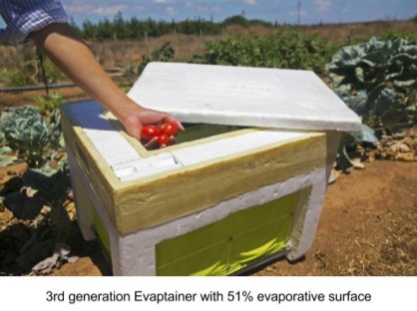Our general approach was to split the grant work into three phases: Ideation/Refinement of Prototype, Manufacturing, then lastly, the Field Testing on the mass produced units. In the Ideation Phase, we would begin by conducting the research and development required to complete the prototype design and create a finished, production quality product. After gathering initial data, we would choose the idea that showed the most promise then work on refining it into a full prototype. During the Manufacturing Phase, we would bring this full prototype to China to begin the process of meeting manufacturers and commencing our intial mass production run. Lastly, once mass production was underway, we would work with freightforwarders to bring 300 units to Morocco, then working with partners in Morocco, distribute some of the units for donation and closely monitor their use, while attempting to sell the remaining units in order to gauge product-market fit.

Phase I - Ideation:

During the Ideation Phase, our team quickly realized that the 3rd generation Evaptainer prototype – the version that was active when we applied to USAID DIV – had several critical shortcomings that would make it impractical to scale. First is that the unit had a high tooling cost and had a projected production and shipping cost at scale of over $100, which was above the desired target. Furthermore, it was incredibly expensive to ship – it is constructed of a rigid EPS foam which is not collapsible; additionally, the shape of water tank on the unit made it impossible for the units to nest into one another, meaning there was no way to ship multiple units efficiently. Thus, simply revising the size and shapes of silicone ports to reduce costs would be an inadequate solution towards meeting all our desired metrics.

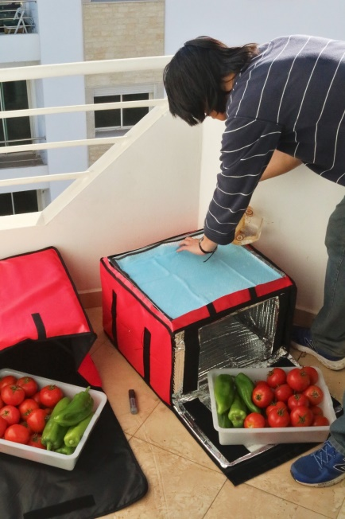We decided to pursue a 4th Generation prototype whose design consisted of a collapsible soft body and used a class of materials called super absorbent polymers (SAPs). SAPs allowed us to create a collapsible unit since we no longer had to worry about having a water tank – rather, the SAP material was simply soaked in water and the gel crystals would swell with fluid and evaporate throughout the day providing cooling. The unit was also constructed of a soft pliable foam (EPE) rather than the rigid EPS of the previous generation, making it possible to roll up and compress. The design was rectangular in shape – 5 sides of the unit consisted of the new soft foam, while the last side (the top of the unit) acted as the evaporative cooling side of the device and was used to hold the SAP material. We hoped that this design would solve the two main problems with our 3rd generation unit. Because the unit was much simpler in design, it would be much cheaper to produce than the previous iteration – we estimated $10-20 COGs per unit. The soft foam would also allow the unit to compress down for shipping.

In May of 2016, we shipped the first 5 disassembled 4th Generation units to Rabat. The [linked video](https://drive.google.com/open?id=0BwqySF_6rYZbbi1YUU5hSmc4SXM) shows us assembling the units at the R&D workshop we set up in Temara. After assembling the 5 units, we started delivering the prototypes to beneficiaries who had been on our waiting list. At this point, we were hopeful that this version would work and we would soon be on our way to producing 300 units for a field trial.

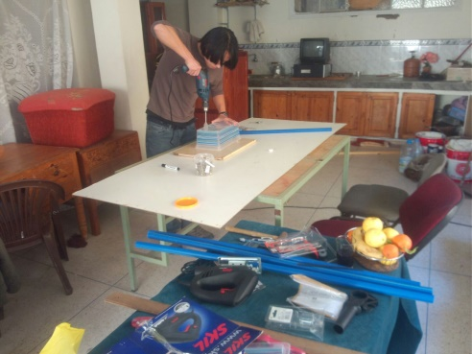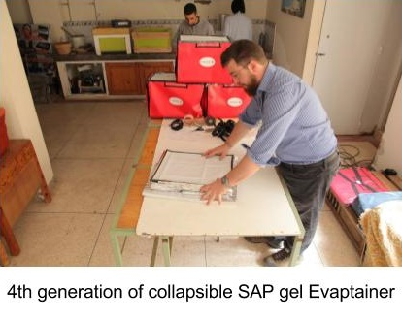

Unfortunately, we discovered 2 problems with these units:

1) First, we learned that an unknown external factor was breaking down and dissolving the SAP material (sodium polyacrylate) we were using in the units after just a week of field use. Interestingly, we had specifically tested both physical and chemical degradation in Boston, using water representative of river water samples in Morocco, but uncovered no degradation. However, one thing we overlooked was sunlight. We did some quick tests at our R&D space in Morocco and discovered it was UV light that was breaking down the sodium polyacrylate crystals. We never discovered this in Boston because all our tests were done inside one of our temperature & humidity control chambers and we had simply overlooked the UV aspect.

2) Next, our users were reporting that there was essentially no difference in shelf life from using the 4th generation units. We knew this was a possibility based on the low evaporative surface area (22%) of the units compared our previous version (51%). Our lab tests also showed lower thermal efficiency readings than the 3rd Generation units (around 40-50% vs. 75-85%), but we had hoped this would not make as big a difference as it did to shelf-life extension.

The discovery of these two flaws put us back to the drawing board in early summer:

First, we explored ways to make the SAPs last longer in UV sunlight. Different gel chemistries were tested. We found that a different type of SAP, potassium acrylic-acrylamide, had a UV life of about 10 times longer than sodium polyacrylate. We also found that a combination of UV protective additives as well as UV absorbing fabrics/shields could increase the sodium polyacrylate lifespan by about 10x-20x. At the same time, we explored a few configurations to increase the evaporative surface area of our units. One design used potassium acrylic-acrylamide and had evaporative surfaces for all 4 side walls. Another design had a trapezoidal shape and used sodium polyacrylate protected by a UV resistant fabric. Both these designs also performed as well as our 3rd generation units in terms of thermal efficiency (75-85%).

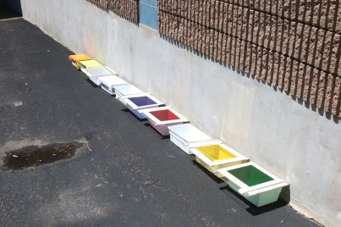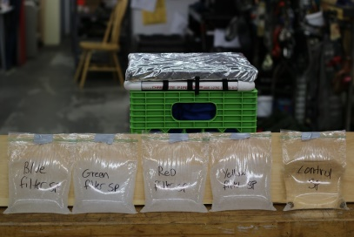

*Figure 2: Testing Gels under UV*

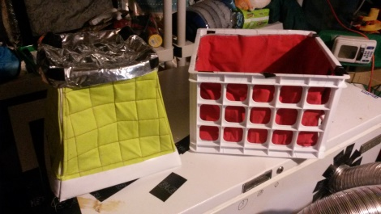

*Figure 3: Different form factors for gel coolers*

*Figure1: Testing different gels*

At the same time, we also realized a breakthrough with a new type of material called thermoplastic urethane (TPU). TPU is an ultra-light polymer typically seen on high-end athletic rain jackets and hydration packs. By reconfiguring and using TPU, we realized we could reach the same efficiency numbers as our 3rd generation units but also streamline the mass-production process thereby lowering the Costs of Goods Sold (COGs) and make the unit much more user-friendly. So while the SAP designs were viable fallback options, we ultimately decided to move forward with our TPU design as the most promising and commercial ready option for the design.

Phase II - Refinement:

After narrowing down the initial design options and selecting thermoplastic urethane as the most promising avenue for development, our team designed a prototype comprised of a high-tech TPU membrane stretched over a solid internal frame. Users could “turn it on” by filling a flow port near the top with water in a single easy step. A large top lid simplified adding or taking vegetables out of the device. Each wall was made from a sandwich of fabric materials with an internal wall made out of TPU and an external panel made from breathable membrane fabric. Because the water is held in the gap between the two, the water usage was incredibly low – on the order of 1/3 of a liter a day. It also meant that there were no unsightly puddles of water formed below the unit due to dripping, unlike the Zeer Pot. The unit could store 60L of produce, and lastly, demonstrated the ability to reduce the temperature from the outside up to 31 degrees Fahrenheit.

This design was stronger and lighter than earlier versions. It could also fold flat like the 4th generation unit, making it significantly more mobile than our rigid field test versions. This would reduce the cost and carbon waste involved in shipping. Unlike the Zeer Pot, this prototype was much easier to use – filling the unit with water was a one-step process that only had to be done once every day or two. The unit made it incredibly easy to see when it needed to be refilled, and as mentioned above, used only about 1/3 of the water as the Zeer Pot.

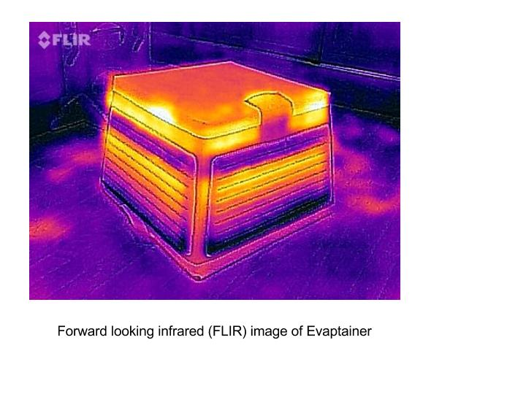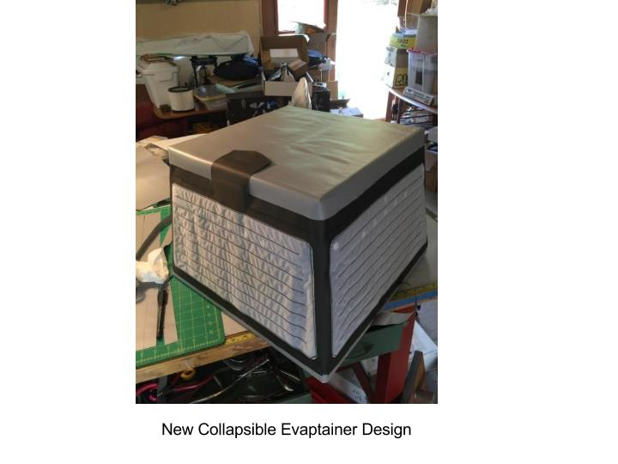

This design was the culmination of the lessons gathered from all of the previous iterations. The membrane material could not clog like the early nozzle designs. Because water vapor passed through the fabric, dust and sand couldn’t build up against the evaporative surface, as with the wet fabric wall versions, robbing it of efficiency. The fabric was more durable and showed less wear than the foam versions, allowing it to look good and last longer.

After creating this prototype, our team rigorously tested it in the same environment control chamber as with our previous prototypes, and proved that it met the same thermal efficiency standards as the 3rd generation units. We also tested the units outside to ensure that they were durable to external factors like sunlight and UV. We then finished our CADs of the device and began talks with different manufacturing companies in China. Along the way, we filed for a provisional patent for this design.

Phase IIIA – Intial, Unscessful Attempt at Manufacturing:

After creating the final prototype design, most of our team’s work and effort was focused on iterating the design towards commercialization and mass production. Starting in November of 2016, our CTO began breaking down the new design into the following components and sought out factories in China that specialized in manufacturing the various components:

1) EPP molding

2) ABS Injection molding

3) TPU film production

4) TPU laminated fabric production

5) 8mm Fiberglass pole manufacturing

6) TPU RF welding of water bladders

7) Custom webbing weaving

We were agnostic about the region in China - we engaged with over 80 factories (sharing as little info as possible and getting signed NDAs when necessary) and started plotting points on a map looking for clusters with skilled producers in densely concentrated areas. We were governing under the assumption that the less we had to transport components, the better off we would ultimately be. Three concentrated areas started to emerge: First, a sizable southern grouping, comprising the Zhujiang River estuary which includes Shenzhen and neighboring Dongguan, Guangzhou and Zhongshan; second, an even larger northern grouping in Hangzhou Bay comprising Shanghai, Suzhou, Hangzhou, and Ningbo; lastly, a much smaller central grouping comprising Xiamen and Quanzhou.

After more conversations, we whittled our potential partnerships down to 56 factories and then pared down the selection to the best 20 for on-site visits and conversations. We then set off to meet them. Ultimately, our goals for heading into China were:

1) To get a better understanding of the vendors and pricing in China.

2) To create a reliable supply chain independent of another company and controlled entirely by Evaptainers.

Based on the above goals, our team created an itinerary to visit Chinese manufacturers between December 6th and 18th, 2016. The main outcomes from the China trip are detailed below:

1. We found a qualified factory for making every part and performing assembly of the current design. This allowed us to move forward independently, without additional outside help of prototyping agencies or manufacturing consultancies.
2. Through extensive conversations with these factories, we gained a better handle of which materials and industrial processes best fit our needs. This meant that we were more knowledgeable about market rates for manufacturing if we ultimately chose to work with an outside contractor.
3. We saw the individual factories and verified that they were both real and had the tools to do what they say they could.
4. We began relationships with these factories by taking the first step of visiting them. They know we are real, they know how to communicate with us, and they know that we are serious about moving forward.
5. We came out with an accurate cost estimation for the COGs of the current model based on manufacturer quotes. This helped us both set a retail price point and evaluate which areas are in need of further value engineering.

After the trip to China, our team had high hopes that the project would finish on time and that the mass production would quickly be underway. However, over several months of production delays with one of the vital components of our device – namely, the TPU material – we realized that we had a much bigger problem on our hands than originally thought.

The problem boiled down to this: we had chosen to proceed with a design that uses a material called TPU for all the benefits mentioned above. Even though our prototypes were successfully created and tested using this material, we discovered that it was much more difficult than expected for our factories to mass produce.

This is because some qualities about TPU itself. TPU is a waterproof plastic that is most commonly seen on hydration bladders on products like the CamelBak. TPU generally is put into various applications through a process called RF welding. While RF welding itself is fairly straightforward (apply pressure and energy to the surface of two materials and bond them together permanently), its application towards our material was not. Because our specialized membrane needed to be breathable to allow water to evaporate (thus creating the evaporative cooling effect) it needs to be incredibly thin. We discovered that our material was so thin that applying too much energy would result in holes being burned into our membrane (a definite problem for something that needs to retain water) and applying too little would cause the two surfaces to not fully bond. This is what our manufacturers could not figure out.

Phase IIIB – Success in Manufacturing:

The originally planned start date of the large scale pilot test with USAID in May 2017 passed by. While we had a prototype, we had no way to mass-produce it. With cash burning from our reserves, our team elected to buckle down and throw every resource we could muster towards solving the dilemma. We researched materials welding and discussed entirely changing the production method; we reached out to our networks, our friends, our old mentors, and new partners. In the end, our persistence paid off. Through one of our networks, we discovered an RF welding expert based in New Jersey willing to help us out. This expert kindly hosted us at his workshop, where we worked together to try to find the correct process for getting ultra-thin layers of TPU to properly bond. In November of 2017, we finally fixed the welding issues and were able to move forward with mass production.

Throughout 2018, our CTO revisited the factories in China and Taiwan responsible for creating the TPU component of our device. After much back and forth, exchanging ideas, and also modifying the design and precise manufacturing techniques, we were able to get a working, properly RF welded TPU bladder. Inevitably, we settled on the finalized design pictured below, and also rebranded the company as Fenik and the product name as Fenik Yuma 60L.

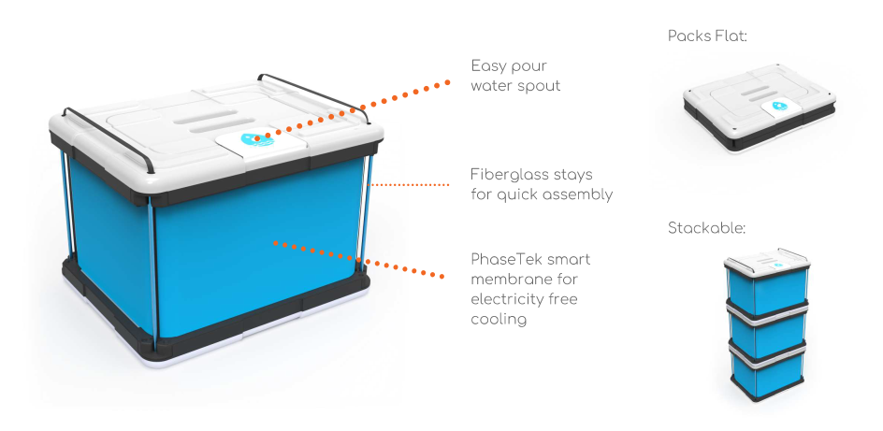

The Fenik Yuma 60L is a light weight, easy-to-carry, fully portable refrigeration unit that can keep perishables like fruits, vegetables and dairy products fresh in the hot summer months. The Fenik Yuma 60L requires no electricity to operate and is 100% eco-friendly with no greenhouse gas emissions. Evaptainers/Fenik makes use of our patented PhaseTek. The technology becomes activated when a user fills the internal reservoir with any source of water (e.g. tap, well, river, lake). The walls of the device then begin to draw out heat from the interior of the device through evaporative cooling. The Fenik Yuma 60L can cool its internal storage space by 15-20 degrees Celsius from ambient conditions.

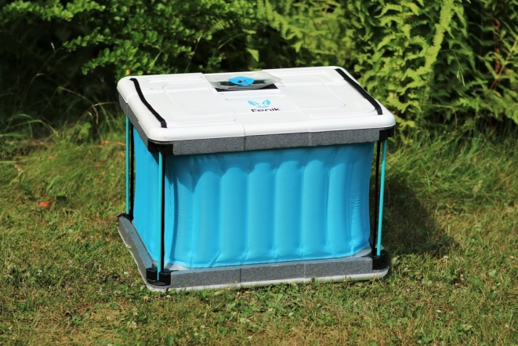 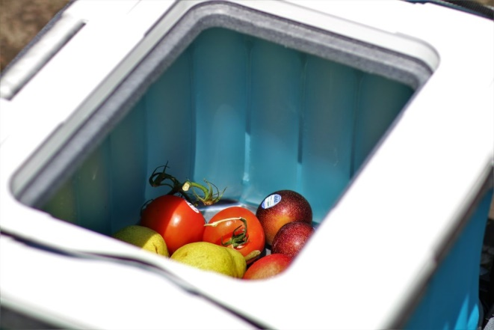

Pictures of the Yuma 60L fully assembled and used with food are shown above.The Fenik Yuma 60L is constructed with a sturdy top and bottom foam piece for durability and robustness. The top foam piece has a lid that can be removed in order to store and take out food. In addition, the top of the device has a flap (seen as a blue raindrop in the picture to the left above) that allows for water to be poured into the unit. Water poured through this flap fills the PhaseTek membrane walls (shown in blue) which then commences evaporative cooling. The top and bottom of the unit are held in place with sturdy fiberglass stays. The purpose of using these stays is ultimately to make the unit fully collapsible. When the fiberglass stays are taken down, the top and bottom lids lock into one another creating a super durable case that protects the rest of the device during shipment:

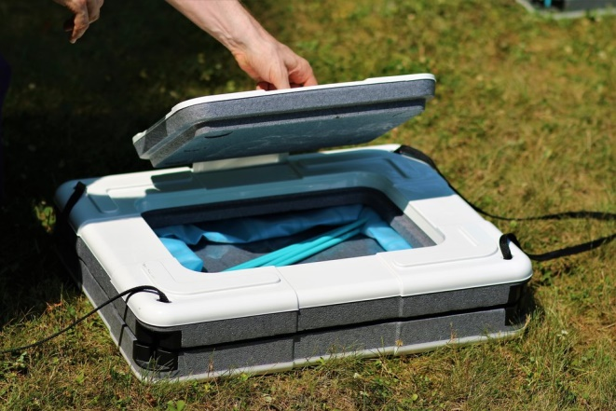Ultimately, the final design is not only cheaper and easier to mass manufacturing than our original prototype, but also has greater usability and transportability based on the unit’s compact size when deconstructed.

Through working with manufacturers, we also completed a bill-of-materials (BOM) that states the minimum order quantities required for each of the unit parts, as well as the price quotes we’ve received from the producers. This gives us a very concrete number on the COGs of the device for our initial run, and is a useful benchmark for estimating the price of production once we reach full scale.

We began our first production run of 500 units in November 2018, and the units were finished around February 2019, for an average COGs of $66. We started a second manufacturing run shortly after the first one finished, and produced an additional 500 units in June 2019.

Phase IV – Field Testing

Around March 2019 - shortly after the completion of the initial production run, our team started making plans to ship the units to Morocco. Coordinating with our freight forwarding company in China, as well as our customs agent in Casablanca, we scheduled the delivery of 300 units to Morocco for the USAID field test. Reserving and entire shipping container, our team delivered the goods via ocean freight, which arrived on Morocco on May 10, 2019.

This initial field test was split into two separate activities:

1. The first activity was to donate 150 units to a rural community in Morocco. The purpose of this was to test the invention on a larger scale to see whether it was used as expected and whether any additional changes needed to be made.
2. The second activity was to take the remaining 150 units and attempt to sell them through various sales channels in Morocco. For these units, we similarly targeted low-income rural areas, similar to the rural community in the 1st activity. The purpose of this was to determine the highest willingness to pay for an evaporative cooler as well as see whether there is a viable sales model for distributing Fenik products in Morocco.

*For the 1st activity involving donated units:*

We began hiring and training enumerators to conduct the baseline analysis for the 150 unit field test while the units were in transit to Morocco. This involved creating the survey instrument itself, then training the enumerators on how to administer the survey via the mobile app. We decided to use a platform called ONA.io alongside the ODK mobile application. We found both tools to be very easy and intuitive to use. Furthermore, they offered Arabic text surveys, which was essential since our enumerators could not speak English.

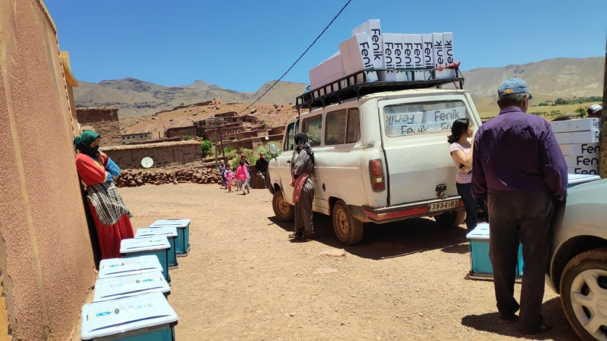After the units arrived in country, we brought them through customs and kept the units at our warehouse in Mohammedia. We took 150 units, and shipped those to Ouarazate where they could be donated to families in need. In terms of field partner, we chose to work with a Morocco based NGO called Association Anmiter. We chose them after speaking to a few other NGOs in the region specifically because of their professionalism combined with their close connection with their beneficiaries. Demographically, the beneficiaries that Association Anmiter worked with were low-income inhabitants of a small rural community in the mid-Atlas mountains called Telouet. In preparation for the donations, Association Anmiter created a list of the 150 families that would be receiving a unit. These units were provided free for the families, and they were allowed to keep them after the trial. The only condition of participating in the field test was a good faith effort to use the devices, as well as their agreement to participate in our survey.

Figure: Donating the Units in Telouet

In early June 2019, our CEO Quang Truong flew to Telouet to meet the Moroccan based field team and officially begin the field test. During the field test, our NGO Partner helped to distribute the units to 150 separate beneficiary families in their region. This was done in the course of a day. The units were loaded onto a large van, and driven around to specific drop points in the small villages around Telouet. The beneficiaries stood by these drop points to maximize the efficiency of the deliveries. When the families received one of the Fenik Yuma 60L devices, they were given a quick demonstration by our Morocco country lead (Yassine Magnouj) on how to set up and use the devices. The families received minimal additional instructions, since one of our tests was to see if the device itself was simple enough to understand with minimal explanation.

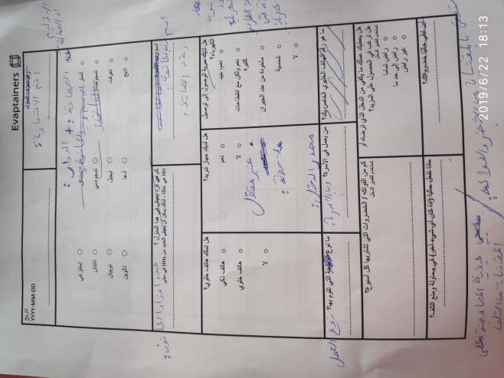After the unit delivery, our team spent the next several days administering the field test. For the field test, we hired 4 enumerators who were college students from the local area that were home for the summer. Their knowledge of the region proved to be incredibly useful for reaching the most remote houses. At the same time, they already had high levels of proficiency with technology, making it very easy to train them on using the ODK application. The baseline data collection was slower than the deliveries, since we had to physically go to each beneficiary family one by one. We took advantage of this opportunity to ensure that the families had properly set up their Fenik devices. On average, the baseline interview took about 15 minutes per beneficiary, and in total we were able to finish the baseline after 3 days.

Figure: Paper version of Survey

Following the baseline, we continued to track and monitor the beneficiaries for the next 3 months. Wanting to be as “light-touch” as possible, this monitoring simply entailed a friendly phone call where we asked whether our beneficiaries were still using the units, or had any issues or problems with the units. Finally, in October we wrapped up the field test with an endline survey. Using the same enumerators from the baseline, we collected the endline data over the span of 4 days. This final survey mainly asked the same questions as the baseline, along with the addition of a few questions to gauge our beneficiaries’ opinions on the Fenik Yuma 60L.

*For the 2nd activity involving 150 units to be sold:*

While the 150 donated units were in between the baseline and endline, the Morocco team set about trying to sell the 150 remaining units through various sales channels in order to assess the market viability of Fenik in Morocco.

One model we tested in particular was whether it was possible to reach our rural consumer segment by advertising and selling our devices at weekly outdoor markets (called ‘souks’) held throughout the country. Souks are a historically and socially important staple of life throughout Morocco and much of the MENA region. They serve as a point of exchange for the redistribution of local agricultural goods, an entryway for manufactured goods from the cities, and lastly an important meeting point and social gathering place for rural communities.

Our strategy was to rent out space for a souk stall in each of the communities to whom we want to sell units. Souk stalls can be reserved through the local authorities at the province level and can range anywhere from free to 50dhs per space per month. Since souks are only held once per week, a sales associate would travel to 4 different souks each week within a small regional coverage zone. Sales associates would conduct all advertisements and sales from the souk stall. Any customer interested in the product would be able to buy on the spot (if there were any remaining units) or reserve a unit to be bought at the same souk the following week. In order to minimize shipping costs, sales associates would only travel with one demonstration unit and however many units were ordered the previous week. Sales associates would also be instructed on how to properly maintain the units.

We attempted this strategy for about three months, but after receiving sufficient feedback and data that this would not be viable, we stopped the “souk distribution model” and pursued B2B models instead. This is detailed further in the next section.

1. **Program Results**

*For the 1st activity involving donated units:*

Of the 150 units we donated to Association Anmiter, 141 units were given directly to single family households, 3 were donated to a local school, 5 were donated to the local authorities, and 1 unit ended up broken.

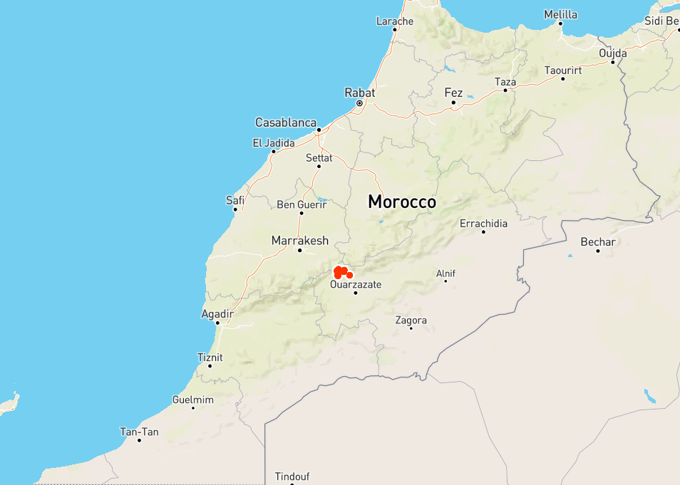The geo-locations of the 141 units that went to single family households are below:

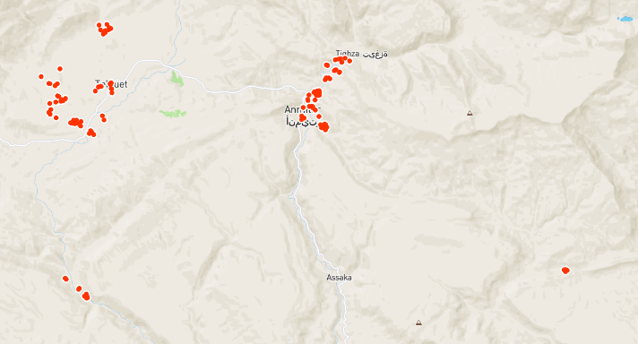

Figure: Locations of the donated units

To provide some additional demographic context, the number of family members in the household ranged from 1 to 20 people, and the median household size was around 5-6 people. The majority of the respondents reported working as day laborers (80), drivers (8), imams (5), or having no job at all (18).

Four families in the in the sample group owned smartphones, 129 people owned “brick” style cell phones, and eight had no cell phone at all.

Interestingly, 129 people also had access to some electricity, and reported that the electricity was “very good”. Three families used electricity from their neighbors while nine had no access to electricity at all. This was not entirely unexpected. When we had done our background research on Morocco in 2016, we found that the country had a rural electrification rate of over 98%, in part because of large government infrastructure programs conducted in the early 2000s. However, our theory was that in our case, electrification didn’t matter as much as access to refrigeration.

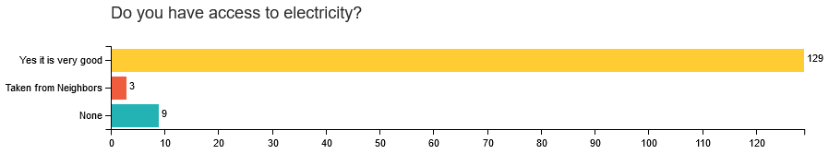

For that question, we found that of the 141 families, only 29 (20.5%) had a working refrigerator. Of the remaining families, 38 (26.9%) reported having a refrigerator, but said that the refrigerator was broken, and 74 (52.4%) families had no refrigerator at all.

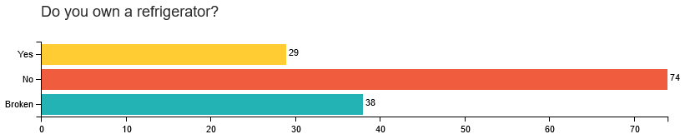

In addition to collecting demographic data, our baseline also asked basic questions about the families’ food and buying habits. For instance, in terms of food storage, 101 families reported placing their food in a box, burlap bag, or simply off to one corner of their house, while 30 reported putting it in a refrigerator. As expected, most families (134) shopped for fruits, vegetables, meat, and dairy exactly once per week at the souk in Telouet.

After the baseline assessment, the team left the immediate area and continued to monitor the progress of the field test remotely. For the next three weeks, the Morocco team made periodic telephone calls to a random sample of the families to check in and see if they were still using the units and whether there were any issues. In total, we reached out to and heard back from 41 families, representing an adequate 30% sample. The results from these check-ins gave us some assurance that the test was going well. The majority of families were still using their units.

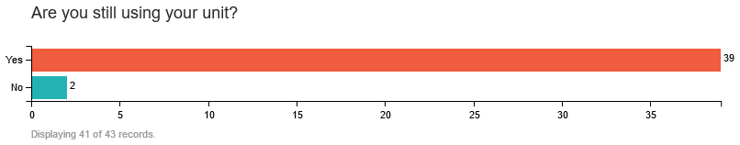

However, our next question about how often they were re-filling their units with water gave us some concern:

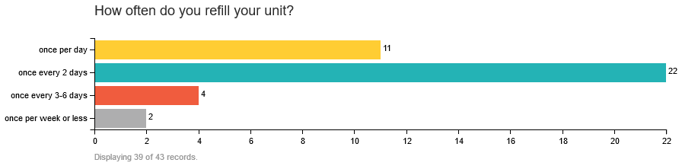

The ideal frequency to refill an evaporative cooler would be every day. Thermal efficiency of the unit is still high if the refills occur every other day. However, if users are refilling once a week or less, then there is a high likelihood that too much of the water has already evaporated from the units and that the device is not cooling to its potential.

Starting in late September, the Morocco team went back to Telouet to formally end the field test and collect endline data. The endline questionnaire essentially asked the same questions as the baseline, with the addition of a few questions specifically about the unit. Additionally, we added in one question at the beginning simply asking the enumerator to check the water level of the device.

In addition to the baseline survey itself, we collected temperature logging USB sticks that we had placed inside a small sampling of units at the baseline as a way to double check that the units were working properly. The initial temperature data is displayed below, with blue representing the ambient temperatures and red representing the temperatures within our Fenik devices:

These loggers captured temperature data at the very beginning of the field test, and were simply used to assess whether the units were reducing temperatures as expected. The graphs all show that our devices succeeded in this light, with Fenik temperatures consistently below the ambient temperature of the room, even reaching a 15F differential in some cases (it should be noted that outside temperatures were even higher – typically around 100F, so the difference between outside temperatures and inside the Fenik would be around 30 degrees). Not pictured above is the humidity, but the Fenik also succeeded at keeping the humidity within the 90-98% range internally, compared to only around 30% humidity outside. Increased humidity is another factor that helps increase the shelf life of produce.

However, tests from our two long-term temperature logging told a slightly different story. These USB sticks collected data once per hour over the course of the 3 month field trial:

The data show that the 2 units started off well. Again, blue represents the ambient temperature within the home and green and red represent the temperatures of the Fenik units. Red and green both start consistently beneath blue, but something notable happens around August 9th. The temperature immediately spikes up past the ambient temperature, implying that the family stopped using the unit. The unit in Anguels seems like it was used for the duration of the field test, but even then there are some times – namely between July 19th and July 26th where it seems that the unit was not filled regularly with water.

Our results from the endline substantiate the above temperature data: that many families stopped using their Fenik unit sometime after the midline survey.

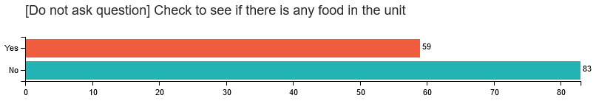

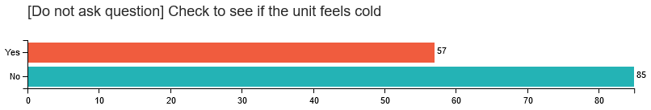

The first two questions of the survey instruct the enumerator to see if there is any food actually in the unit at the time of visit. The data show that by the endline, a majority (58%) had elected to stop storing food in their Fenik. The enumerator was also asked to reach inside the unit to see if it still “felt cold”. Unsurprisingly, the ones with food stored in their units continued to fill their units with water and keep them operational. Also unsurprisingly, when we asked the respondents directly if they were using their units, the distribution was almost the same (56 said yes, 84 said no).

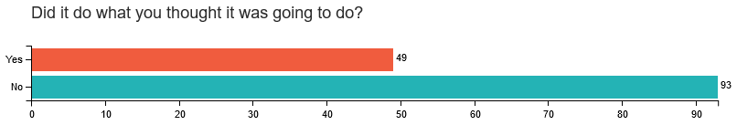

When we asked whether the Fenik had met our user’s expectations of what the product would do, the general distribution was again the same. Overall, the general opinions of the product seemed negative and that the product did not succeed in helping our beneficiaries save money. In fact, the average score for the question “Would you recommend this product to a friend” was 3.75 out of 10, and only 3 respondents said that the Fenik Yuma 60L helped them save money at all.

Paradoxically, though, when we asked indirect questions about whether the Fenik devices worked properly, or helped save money, their latent responses indicated that our devices had actually been quite successful. In other words, when we conducted the baseline, we asked questions about the average shelf-life and spoilage of their foods. When asked the exact some questions for the endline, there were strong indications that the recipients benefited from the device by increasing the shelf-life of food.

First of all, we discovered that the aggregate shelf-life of food went up between the baseline and endline, even when including those that stopped using the unit midway through the study. When we filtered the results to only the families that reported still using the unit, the impact became even more pronounced, rising from 4.334 days on average to 5.145 days.

We also saw that the average food lost to spoilage went down. In the baseline, we asked respondents to come up with a list of all the perishable foods they bought in a week, then for each item, we asked “About how much (in dirhams, the local currency) do you discard per week?” The above chart shows the sum of all the food they discarded in a week. In the baseline, respondents reported losing 6.36 dirhams per week. For the endline, this number dropped to 2.70 dirhams, and just 1.345 dirhams for respondents that used the Fenik till the end of the survey. This average savings of 5 dirhams per week is pretty significant, so we were surprised that so few people actually perceived a savings of wealth.

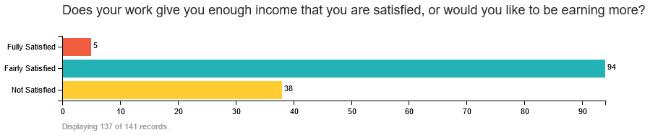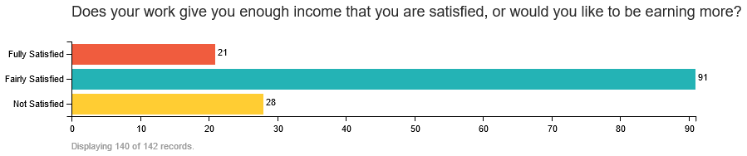

Intriguingly, more people also reported being happy about levels of wealth between the baseline and endline. When asked “Does your work give you enough income that you are satisfied, or would you like to be earning more?” the number of respondents that reported being fully satisfied increased from 5 to 21. In terms of the recommendation score, that too rose when considering only people that actually used the unit the entire way through (3.75 rising to 6.0).



*Baseline*

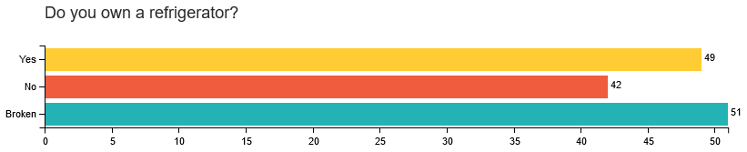

*Endline*

Lastly, it was interesting that beneficiaries saw the Fenik device as a refrigerator rather than simply an evaporative cooler. The number of people who reported owning a fridge rose significantly between baseline and endline, and our enumerators definitely did not notice that there was an actual new electrical appliance in the beneficiaries’ households. Therefore, many considered the Fenik to be a refrigerator, though it should be noted that many also categorized it as a “broken refrigerator”.

The big question then, is why was there such a mismatch between perceived utility and actual impact? And moreover, why did so many people stop using the unit half way through the field trial? In the last month, our team has gathered additional data and followed up with the beneficiaries to find out more information. We now believe we have some very plausible explanations, most of which are easily controllable factors in future interventions, but unfortunately ones that we simply overlooked for this first field test:

1. Mold: The number one issue that we overlooked entirely during the field test was the possibility for mold to form within the Fenik devices. The reason that we overlooked this was because during internal testing, we handled food in a very specific way that represented “best practices” for storage of produce. This meant rinsing fruits and vegetables with water, then thoroughly drying the food with a paper towel before placing it in the unit. What we discovered was that because the Fenik device keeps a high relative humidity (this is part of what helps preserve fruits and vegetables) when the smooth TPU walls of the device get cooler during the night, beads of condensation form on the interior walls of the device. This condensation, combined with the humid environment and fruits and vegetables which may have not been washed, create a breeding environment for mold to spread. Mold was the most frequent response that our beneficiaries gave when we followed up with them after the field test. They recollected using the units for the first few weeks, but once they began to see mold, they stopped using the Fenik devices. Fortunately, there are a variety of ways to solve this issue. The long term solution would be to change the interior backing of the PhaseTek bags so that condensation is less likely to form. This would not affect the COGs of the unit, but wouldn’t be possible until the next production run. However, another very simple and immediate fix would simply be to instruct users to wrap whatever food they place in the Fenik in a piece of paper, a paper towel, or just a brown paper bag. We have tested this ourselves and with a few of our field partners and have confirmed that it is a workable solution.
2. Mismatch of expectations: Secondly, we realized that when we initially told our beneficiaries about participating in the field test, we advertised our device more as a refrigerator than an evaporative cooler. There is actually not a good Arabic translation for evaporative cooler, which is why we used tleja, which means fridge. This is one explanation for why respondents in the endline reported owning a “refrigerator” after receiving one of our units. However, the high expectations that came with the word refrigerator likely led to much disappointment and missed expectations. Beneficiaries seemed most excited about being able to use the device to store meat, and when they discovered that it would not get as cold as a conventional refrigerator, they became disappointed in the device.
3. Not enough instruction: Third, we realized that our assumption of the device being “easy to use” was flawed. Even though the process of assembling it and filling it with water was simple, there is still a lot of nuances in terms of what foods should be kept inside, how often to refill the unit, and lastly how to properly handle the food before it goes into the unit (see point #1). Each unit we donated actually did come with a full set of instructions that detailed how to properly maintain the unit and properly store food inside. However, one major oversight was that these instructions were in English and were never translated over to Arabic or Berber for the beneficiaries. Consequently, all they had to go on were the pictures on the instructions and our initial directions when we delivered the unit.
4. One last factor for the negative reactions towards our device has to do with Morocco itself. Generally speaking, Morocco’s average level of wealth is much higher than many other nations in Africa and especially sub-Saharan Africa. In terms of electrification, Morocco has over 98% of rural areas connected to the grid. Initially, we thought that it was the refrigeration rate that mattered more. We now believe that even in the very remote area that we chose to pilot the device, people are already accustomed to conventional refrigerators, and have strong expectations for what refrigeration can and should do. This means that even though Morocco may have a more limited need for this type of devices, we are still confident that other countries throughout Africa and the world will have a strong need and desire for evaporative cooling products.
   1. **Next steps**

Although our initial field trial was not a complete success as hoped, the data we gathered definitely painted a positive picture for the effectiveness of the Fenik device if used properly. Our data showed that users were able to both increase the average shelf life of their goods, and reduce the amount of food they throw away due to spoilage. We believe these impacts would be even greater had we controlled for certain factors during the field test.

To that end, we are already moving forward with a second field test where we directly address the issues above to see if we get better results. This field test will take place near Laayoune, Western Sahara starting mid-December and will be done in partnership with the Siemens Foundation. We believe that the Western Sahara will be a better place for the field test because the region is much less developed than Morocco and definitely has a greater need for a product like the Fenik device. This unit will be smaller and will target 40 beneficiaries, so that we can spend more time with each beneficiary to ensure that they understand how to use the unit. We will be sure to present the unit as an evaporative cooler, rather than a refrigerator, and lastly are planning on printing a set of instructions in Berber that describes the proper way to store vegetables inside the unit to minimize the spread of mold.

Additionally, we are in talks with the World Food Program to run a larger pilot (of between 100-200 units) with their country office in Somalia. This pilot would focus on retailers who have no access to electricity, as a potential solution to allow them to keep fruits in stock.

Lastly, we are testing with MIT on an evaporative cooling project in Mali, as well as with a social enterprise in Kenya called WeTu (in partnership with Siemens Stiftung) to test our devices with food distributors using e-bikes to deliver fruits and vegetables sometime in 2020.

1. **Cost-effectiveness & Competitive Landscape**

Compared to other solutions that provide off-grid cooling, the Fenik – even at our low production quantities – is an incredibly cost effective solution. For example, one competitor product is the Vakava QuickCold 120 (<https://vakava.com/>). The QuickCold is a sturdy, well-insulated metal box that can keep temperatures as cold as refrigerators by using dry ice. These boxes are twice the size of the Fenik 60L, however, they cost 6 times more than the Yuma 60L and weigh 27 kilos when empty. Despite being able to offer colder and more consistent temperatures than our device, it is difficult to imagine how a base of pyramid consumer, or shop keeper can purchase something that costs USD $600 and expect it to pay itself off. Another competitor, the FreshBox, has an even higher price point. The FreshBox is a larger, walk-in refrigerator sized device. These work on solar panel power and cost USD $10,000 per unit. Both these products are sold worldwide and readily available in a country like Morocco, though neither have a strong presence in the country.

By comparison, our costs are currently $66 per unit. It is important to note that these are the costs for our initial small batch runs 500 units, and the price will fall dramatically once we start large manufacturing runs. At this cost, we sell to U.S. consumers at a retail price of $150, and also sell in bulk to distributors and NGOs at $100 per unit. At scale, we believe we can drive down the unit costs to around $30, which would allow us to sell to NGOs for around $60/unit, a full 1/10 of the cost of the Vakava. Furthermore, we would like to continue developing the PhaseTek material into lighter and cheaper products. For instance, we have discussed scrapping out the fiberglass stays and the top and bottom shell and just creating an “evaporative cooling bag” that can simply be hung from the ceiling and keep food cool. It may be possible to produce these as cheaply as just $10 per unit, and sell for $20 – $25 retail. Given that our current field test data show an average savings of 5dhs per week (around USD $.50) this implies a pay-back period of 40 weeks, not even factoring additional savings such as reduced trips to the souk, or time saved from shopping that could be spent on income generating activities.

For storage of products like meats, or vaccines, a device like the FreshBox or Vakava is definitely crucial, since evaporative coolers cannot maintain a low enough or consistent enough temperature. However, for products with less stringent cooling requirements like fruits, vegetables, dairy, and insulin, the clear winner would be a Fenik device. These are just hands down lower in cost, they require no complicated supply chain to use (i.e. working solar panels or a supply of dry ice) and are flat-packing, which makes eventual distribution ultimately much easier.

1. **Distribution**

Even considering the cost effectiveness of the Fenik Yuma 60L compared to other competitive products, it will still be difficult to determine ways to distribute the product to base of pyramid consumers. As mentioned above, part of the field test was to test a direct-to-consumer model where we sold the Fenik devices at the weekly markets, or souks.

After the summer testing our souk model, we made the determination that it was not a financially sustainable sales model, especially with the current COGs of our device. Specifically:

1) The product price is just too high for what people in rural souks can reasonably afford: We initially started souk sales at a price of $80 per unit, which we realized was high, but much cheaper than what American consumers were paying. After seeking advice on business models from other social enterprises, we hoped that positioning the product as a high-end consumer product from a U.S. company name brand would make the product more appealing with customers. We quickly discovered that lower end customers were so price sensitive, that things like brand name really carried no weight.

2) Souk customers also did not value the “high-tech” aspect of the PhaseTek material either. Instead, when the held the Yuma 60L, the remarked that it felt “too light” and couldn’t understand what they were paying for (throughout many developing markets, people associate weight with value because it implies it has more material). They also commented that the foam top and bottom made the unit seem cheap, and that the fabric seemed like it could be fragile.

3) Another issue was the vastly different expectations Moroccan consumers had compared to sub-Saharan African markets: Moroccan consumers wanted something that could get cold enough to store meat, which an evaporative cooler won't ever be able to do. Because of the high consumption of meat and the wider access to electricity and conventional refrigerators, the higher price point Fenik Yuma really struggled to find a good market niche for BoP consumers in Morocco.

Throughout the summer, we kept dropping the price of the unit at souks, first from $80 to $70, then from $70 to $60 and finally to $50 (which was now well below the $66 COGs of the device). Still, there was no one in the low-income rural areas we sold willing to purchase at this price. After getting feedback from the customers at the souk on how much they would pay for the device, the general consensus seemed to be around $25-$30, which is even below what a mass produced, theoretical COGs for this unit could be. This is also similar to the price point that our beneficiaries in Anmiter gave when they were asked how much they would buy the unit for. Therefore, we decided that there was not a strong product-market fit and that we would need to redesign the Fenik device to be much cheaper to appeal directly to BoP customers.

Instead of focusing on direct-to-consumer models, we focused on B2B sales and cross-subsidized models. We initially hoped that it would be possible to sell our unit directly to low-income consumers, but for now this seems like the most likely path forward while our unit cost is as high as it is. It's definitely been slower to reach out to consumers this way, but the benefit is that the model is financially sustainable.

So far we've sold/distributed 55 units via selling to development agencies/NGOs (50 to Siemens Stiftung for a field trial, two sample units to local authorities in Western Sahara, and three to the NGO Corps Africa). We also have a bunch of other testing outside of Morocco and are hoping this will eventually net us sales - but again, this channel is just slower to get started up. We have MIT testing a unit in Mali, WeTu testing 5 units in Kenya, and we are trying to work out another bulk sales deal/pilot test with the World Food Program in Somalia as well as Algeria. Via cross-subsidization, (i.e. buy one give one model), we've managed to distribute 78 units.

1. **Scaling Plan**

As it stands, we have high enough demand in the U.S. market to continue sustaining ourselves as a company. The price for the Fenik Yuma 60L on our website is $149.95, giving us a gross margin of about $70 dollars per unit once shipping, customs and duties are factored. Additionally, we have very little overhead: much of our website traffic comes from organic searches and our online store is completely integrated with our 3PL warehouse, meaning a part-time employee could maintain the “low-capacity” operations of the company simply by placing an order of 500 or 1,000 units to our manufacturers whenever our inventory runs low, and ensuring the website is running smoothly.

However, under the “low capacity” scenario described above, the only viable markets would be U.S. consumers and development agencies/foundations that wish to purchase the Yuma to donate to their beneficiaries. Since our goal in starting Evaptainers has always been to create a product that can reach the base of the pyramid consumers, our intention is to lower our costs of production so that the Evaptainer/Fenik can reach as many people possible. Luckily, there are very straightforward ways to reduce our COGs so that we can sell competitively to low-income consumers:

* 1. Commit to larger production runs: the most straightforward way to reduce our COGs is simply to produce more units. As mentioned above, production runs of 500 are incredibly small and expensive as far as manufacturing goes (factories typically expect receiving orders on the scale of 10,000 – 1,000,000 units). Even without implementing any cost-saving redesigns, simply scaling up our operations can drop our COGs 20-30%, which would reduce our costs to around $46 per unit.
  2. Move more of the manufacturing to China: Another large reason for the high cost is because of the cost of the membrane. Because our specialized membrane is somewhat difficult to produce, we wanted to “play it safe” with our initial product run by choosing a manufacturer in Taiwan that could handle the intricate RF welding required to make the PhaseTek. Unfortunately, we discovered that there is an 80% tariff on thermoplastic urethane products coming from Taiwan into China (China is where we handle final assembly). This fact, combined with the fact that Taiwan manufacturing is simply more expensive than Chinese manufacturing, led to a high price for the membrane component cost of the Fenik Yuma 60L: after the duties and shipping costs are accounted for, the PhaseTek component costs about $36 just by itself. By finding a Chinese factory capable welding, we believe we will be able to reduce the price of the membrane down to around $18. This is based on just factoring away the high cost of duties and estimating a lower price based on the typical price difference between Chinese and Taiwanese manufacturers. Finding the right Chinese factory will take a little bit of work – it will likely involve sending one of our engineers to China for about 3 months to visit different welding factories and work out any technical hurdles involved in getting the welds to properly form. However, since we now have a working product that we can demo, we are confident that finding a lower cost manufacturer in China is only a matter of time, rather than a matter of innovation.
  3. Make the unit smaller. One final and very straightforward way to reduce the price of the Fenik Yuma is simply to make it smaller. Based on some very preliminary feedback from our beneficiaries, 60 liters is probably a bit too big for a family of 4. Reducing the size to between 30-40 liters will have the benefits of: a cheaper unit from less material costs, lower costs for freight (since more units will fit inside of a shipping container) and finally reduced costs for final distribution.

In total, combining the cost savings from economies of scale, from moving our manufacturing, and from reducing the size of the unit, we believe we can create a Fenik Yuma design for around $30 COGs, with an MSRP of between $70-99 in developing countries. Based on all the market research we have done to date, we believe this would be a very competitive price range, as it compares with home solar lighting kits, and is still far cheaper than a conventional refrigerator (which typically sells for $150 or more). Feedback we’ve gotten from distributors in developing countries also indicate that any price under $100 is likely to have a strong market for consumers who still don’t have access to refrigeration.

* 1. Beyond the changes mentioned above, it is definitely feasible to reduce the COGs even further. For instance, consolidating the number of factories we work with (currently we work with about 5) will reduce shipping costs between factories. Furthermore, sending a cost-engineer to our factories to streamline manufacturing processes could reduce mass production COGs even further. Lastly, we can develop different and completely redesigned products specifically geared for base of pyramid consumers. For instance, we have discussed designing an ultra-low cost version of the unit which is essentially just an “evaporative cooling bag” that can be hung up in someone’s house that would store food. Alternatively, we can create a membrane that wraps around a commonly used crate or container in a particular country. It would likely be possible to sell these around the $50 price point. For now, though, since we already know that the Fenik Yuma 60L design works, our intent is to reduce the costs of that design as much as possible before branching off into other alternatives.

How we get there:

Going from a $66 COGs to a $30 COGs seems like a big leap, but it is actually a much smaller step than anything we’ve done to date. To put things into perspective, we were able to go from the initial idea of a “modern evaporative cooler”, through 8 different iterations of prototypes, various stages of product testing, and finally the production of the Fenik Yuma 60L for total budget of around $600,000. In terms of reducing the COGs to $30, we estimate it will cost about $200,000 to create a lower cost supply chain with Chinese manufacturers while redesigning a smaller and cheaper unit, and then about $300,000 for the capital expenditure required to commit to a product run of 10,000 units. We are looking for a wide variety of sources for this funding, but the most likely options are listed below:

* Private Investment: We are currently working to raise a Seed/Series-A investment of between 1.5m-2m at a valuation of around 10m. $500k would be used to bring down the costs of the device, and the remaining money would be used to pay founders’ salaries, hire additional staff, and begin expanding our marketing and distribution presence. We previously received small bridge-investment in early 2018 at a valuation of 2m through the SparkLabs accelerator program while we were still in the midst of our manufacturing issues. We believe - now that we have figured out our production issues, have a working product in the market, and have run a successful Kickstarter - that there will be a viable level of interest in our company from an investment perspective. We plan to start reaching out to the networks that have supported us in the past, including the Siemens Stiftung network, the Sparklabs Network and the USAID-DIV network, to see if they can make introductions to interested investors. We also already have a pitch deck and business plan ready for sharing (in Appendix).
* USAID-DIV Stage II grant: Contingent on the results of the USAID-DIV Stage I pilot, we would also be interested in applying for a Stage II scaling up award. Already, we have interest from our product in variety of places- from Morocco, to Kenya, India and Nigeria – all of which would make great potential locations for a scale up project.
* Continue running pilots with other development agencies: One last way forward would be to continue running pilot tests throughout different locations with foundations and development agencies. For instance, we are in talks with the WFP about doing a large scale pilot that the test the usability of the PhaseTek membrane for shipping and transit of agricultural goods. We are also in talks with Siemens Stiftung about running a pilot in the Western Sahara with the OCP foundation. These pilots are relatively high margin for us, and would allow us to save aside money to eventually send an engineer to China in order to reduce the costs of manufacturing. They would also allow us to establish beachheads in new markets and get featured in a wider variety contexts and climates throughout the world.

1. **Feedback for USAID** 
   1. All in all, USAID DIV has been an essential partner to us for the last 4 years. At the onset of the DIV process, we were only three co-founders with a prototype. Today, we are a fully functioning company with patents, customers, a Morocco ground team, and a working supply chain. Completing the Fenik Yuma 60L and bringing it to market definitely would not have been possible without the DIV program.
   2. By far, the biggest value-add of DIV’s financial support was allowing the co-founders to pay themselves while pursuing the project. This allowed us to temporarily leave our jobs and pursue the project full-time. The financial support also allowed us to have the capital required to complete our R&D, order sample materials, prototype, create molds, and begin mass production. Throughout the process, the DIV team was very flexible and accommodating. This was extremely helpful since our engineering pathway was not always straightforward. We made critical discoveries throughout our product development which necessitated drastic changes to the design and project timelines. Had DIV not been as flexible or patient with us, we definitely would not have had the space to develop the product we have today.
   3. Aside from financial support, the biggest benefit received from DIV was the boost in credibility for the company. As mentioned earlier, our team ran into numerous engineering hurdles which delayed our timeline and caused us to go over budget. We were able to raise additional funds to keep the company afloat, in part because USAID is a well-known entity in the development world. New funders that came onboard (i.e. SparkLabs, MassCEC, Siemens) did so partially because the stamp of approval given by USAID eased many concerns they may have had about working with a small startup. In addition to credibility, the social media exposure from being re-tweeted, or mentioned in a USAID newsletter helped our company build our own social presence, and was particularly useful during our Kickstarter campaign.
   4. Compared to other funders, DIV was much more hands-off, which had both benefits (mentioned above: the flexibility allowed us the space to be creative) as well as drawbacks. One of our funders, Siemens Stiftung, was more active in an advisory role and able to help us with a specific technical issue by reaching out to their network of engineers. This ultimately allowed us to solve the TPU welding issue. Another funding group (SparkLabs) focused around creating a cohort of entrepreneurs that entered their program around the same time. This allowed the founders to share lessons and also important contacts with one another (for instance, contact names of distributors or trusted manufacturers in China). SparkLabs also gave entrepreneurs exposure to a network of investors through a Demo Day, where each of us pitched our business on stage. However, these examples are not to say that USAID DIV should attempt to emulate the other funders. I don’t believe it’s necessary for one funder to “have solutions for everything”, and certainly what USAID provided - funding, flexibility, credibility, and exposure - was very valuable.
   5. However, there are ways I believe that DIV could improve. Currently, Fenik is in a program with the World Food Program called the “WFP Sprint”. In a “Sprint”, a startup is assigned an internal WFP “champion” who attempts to promote a company’s technology or solution within the WFP system. If the champion is successful and a WFP country mission takes interest in a specific startup, the Sprint program grants up to $100k for the startup and country mission to work together on creating a 6-month pilot project (so the mission pays no money). In my opinion, DIV could do something similar to this. One of DIVs greatest assets is that it is housed within USAID, and potentially has relationships with USAID country missions. Building connections between DIV recipients and the country missions would be an immediate way to springboard solutions while quickly being able to demonstrate real-world results. It would also be a rapid way of seeing whether a solution in one country might work in a completely different country.
   6. In terms of continuing to support Fenik, sales leads (or pilot testing leads) would definitely be a high priority for us. Our company would be interested in seeing whether there are any other spoilage reduction projects that could benefit from the use of our device. Another priority is raising additional funds, either from grants or impact investors. This would allow us to engineer costs out of our device, making it cheaper and more widely accessible. Pending the results of our follow-up study in the Western Sahara, we may be interested in applying for Stage 2 DIV funding. Additionally, if the DIV team is connected to any social investment networks, we would be interested in showing around our pitch deck.